LibraryHub

Problem Statement

This is a library management system to manage library items, registered members, loans, returns,renewals, waiting lists or reservations, overdue items, fines and borrowing history

The system should apply library rules to borrowing and returning operations, tracks due dates, manages reservation queues and identifies overdue loans.

The initial implementation is python based system further implementing dsa, sql and react interface in the later stages

Main Objectives

- maintaining records of books, magazines, and reference items
- maintaining records of different member types
- need to record loans, due dates, returns and renewals
- manage reservations using a waiting queue
- calculate fines for overdue returns according to given rules
- Provide overdues and borrowing history
- handle invalid requests

Requirements

- Manage library items (add or find book)
- Manage members (registration or finding)
- borrow (create loan when borrow is allowed)
- return items (record items returned and calculate if any fine applies)
- renew loans (renew smtng only if rules permit)
- reservations for unavailable items (add member to waiting lists)
- track overdue loans (identify loans past their due dates)
- maintain history (retain records of borrowing and returns)
- produce reports

UML Diagram Description

Classes - objects tht my system will build
attributes - information each object stores
methods - operations each object performs
inheritance - which class extends other class
associations &
compositions - how objects are connected

- CLASSES:

LibraryItem(abstract) | common behavior for library items
Book | representing a book
Magazine | represents a magazine
ReferenceItem | represents a reference item
Member(abstract) | common behavior for members
StudentMember | represents a student member
RegularMember | represents a regular member
PremiumMember | represents a premium member
Loan | record borrowing relationship(who borrowed what), dates, return state
Library | coordinates items, members, loans and library operations

- INHERITANCE

Book, magazine, reference item --(INHERITS)--> LibraryItem

StudentMember, RegularMember, PremiumMember --(INHERITS)--> Member

Loan Class: should know which member borrowed which item, when the item was borrowed, when it is due, and whether it was returned.

Library Class: coordinates everything, maintains collections of items,members and loan records and exposes operations such as borrowing, returning and searching

- UML DIAGRAM (Structure of the system)

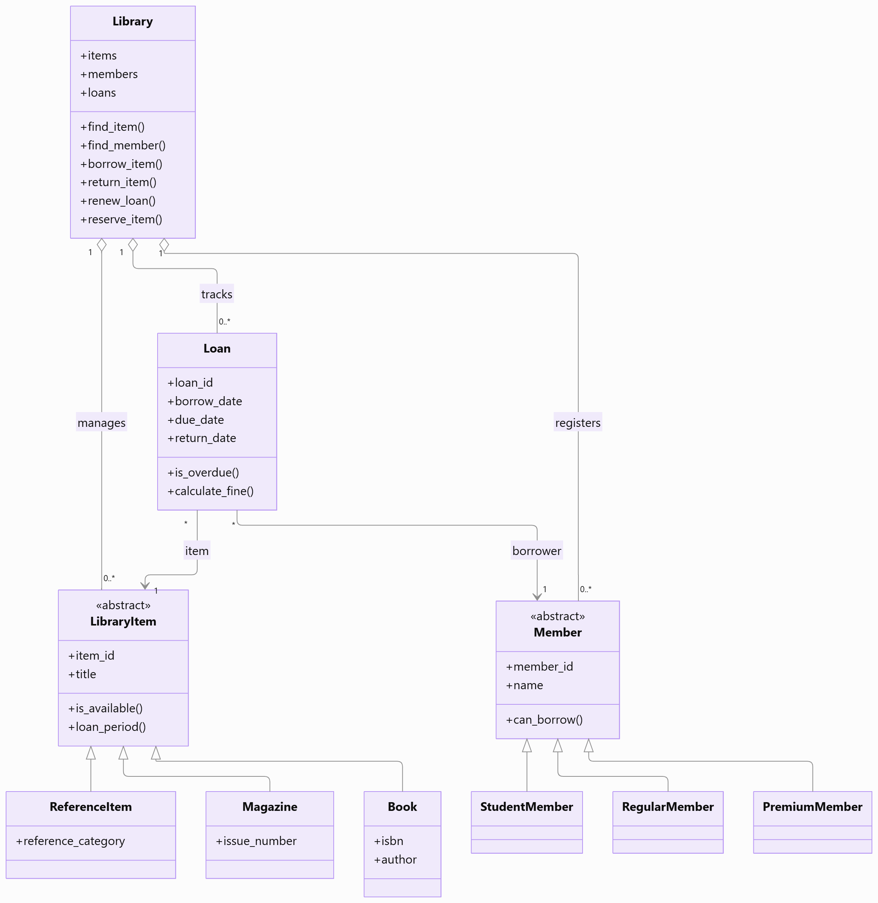
- Exceptions

- ItemNotFoundError — the requested item does not exist.
- MemberNotFoundError — the member does not exist.
- LoanNotFoundError — no matching loan exists.
- BorrowingLimitError — the member cannot borrow more items.
- RenewalNotAllowedError — the renewal violates a rule.
- ItemNotAvailableError — the item cannot currently be borrowed.

CRC CARDS
Class – Responsibilities – Collaborators
LibraryItem (Abstract Class)
Common parent class for all library items.
Responsibilities:
• Stores ISBN, title, authors, category, pages and price.
• Validates the ISBN.
• Maintains total copies and available copies.
• Defines common item behaviour and loan-period behaviour.
Collaborators:
• Book, Magazine, ReferenceItem, Library, Loan
Book
Represents a book available in the library.
Responsibilities:
• Stores book-specific information.
• Can be borrowed and returned.
• Can be renewed according to the library rules.
• Uses the borrowing member's loan period.
Collaborators:
• LibraryItem, Library, Loan, Member
Magazine
Represents a magazine available in the library.
Responsibilities:
• Stores magazine-specific information.
• Uses a fixed loan period of 7 days.
• Cannot be renewed.
• Tracks magazine availability.
Collaborators:
• LibraryItem, Library, Loan
ReferenceItem
Represents reference material that can only be used inside the library.
Responsibilities:
• Stores reference-item information.
• Identifies the item as non-borrowable.
• Prevents reference items from being borrowed.
Collaborators:
• LibraryItem, Library
Member (Abstract Class)
Common parent class for all registered library members.
Responsibilities:
• Stores member ID, name and email.
• Defines borrowing limits and loan periods.
• Defines the daily fine rate.
• Maintains unpaid fine information.
Collaborators:
• StudentMember, RegularMember, PremiumMember, Library, Loan
StudentMember, RegularMember and PremiumMember
Represent the different categories of library members.
Responsibilities:
• Define membership-specific borrowing limits.
• Define membership-specific loan periods.
• Define membership-specific daily fine rates.
• Follow the borrowing and renewal rules.
Collaborators:
• Member, Library, Loan
Loan
Represents a borrowing transaction between a member and a library item.
Responsibilities:
• Stores loan ID, borrowing date and due date.
• Tracks return date and return status.
• Checks whether a loan is overdue.
• Calculates overdue fines.
• Handles renewals and tracks the renewal count.
Collaborators:
• Member, LibraryItem, Library
Library
Central class that coordinates the library operations.
Responsibilities:
• Maintains collections of items, members and loans.
• Adds and retrieves items and members.
• Handles borrowing, returning and renewing.
• Manages reservations and waiting lists.
• Generates overdue reports and searches the catalogue.
Collaborators:
• LibraryItem, Member, Loan, Audit
Audit
Records important operations performed in the library.
Responsibilities:
• Records successful borrowing operations.
• Records successful return operations.
• Records successful renewal operations.
• Stores the time, action, member and item details.
Collaborators:
• Library, Member, LibraryItem, Loan

